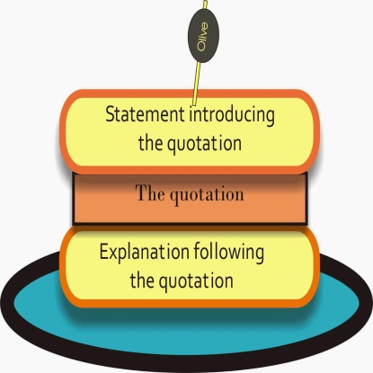
Using text based quotes in your quick write response
(QUOTE SANDWICH)

You cannot just throw a quote into your quick write as its own sentence. You must introduce it first, then state the quote, and finally explain its relevance/significance to the point you’re trying to make. We’ll call this a QUOTE SANDWICH.

- Introduce the quote:
- In the text, Bradbury writes, “…….”
- According to George Hadley, “…………”
- At the end of the story, Peter says, “………….”

- State the quote
- “The lions were coming. And again George Hadley was filled with admiration for the mechanical genius who had conceived this room.”
- “Nothing’s too good for our children.”

- Explain the relevance/significance of the quote to your point
- This shows that…
- This reveals that…
- This quote means…
Quick Write Pointers
- Use the bullets as a checklist
- Indent only ONCE at the beginning of your response. It is only a paragraph you are writing
- Make sure that both details you choose to use as evidence relate to the topic sentence
- Make sure that both details you choose to use as evidence are the STRONGEST pieces of evidence to select from the story. Ask yourself: Could I find something better than this in the text to prove my point? This is called “determining importance” and it is a skill you are expected to master this year.
- Make sure you explain how both text-based details support the answer to the question. Do this one at a time. In other words, state the first detail and then explain its significance. Then state the second detail and explain its significance. Your explanation should reflect thoughtfulness, insight and a thorough understanding of the story.
- Check your spelling, capitalization, punctuation, and word usage. There is NO EXCUSE for spelling words incorrectly when they are right in front of you on the page.
- Read over your work OUT LOUD when you finish to catch mistakes with your ear that your eye may have missed.

